<https://member.malagroup.org/secure/kyclist.php>

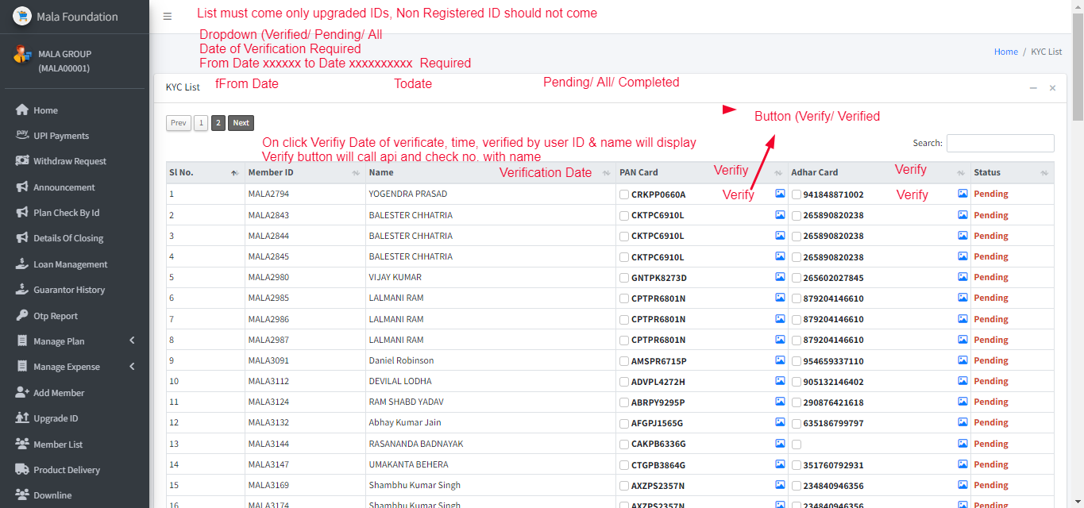

List will come only upgraded IDs

Once Name changed then automatically Pan & Aadhar will ask to upload or rekyc required, user must update aadhar & Pan (Previous aadhar & pan will be available intact

KYC will be changed Pending once change the name/ DOB/ Father/ E-Mail ID/ Mobile No.)

Previous data will be display as history

1st time kyc will be free but every next time it will charge @150/-, wallet will be deducted even if balance is not available

User can themselves user verify option, though API it will automatically very and admin can see who has verified

We need a check box in setting page column

Enable Hold transaction for non KYC verified

User can’t transfer/ upgrade ID/ Withdrawal request but can recharge (all options are based on enable / disable option